AKC Rally Titles:
Rally Novice (RN)
Date: |  | Score:
 | Leg 1
 | Leg 2
 | Leg 3
Rally Intermediate (RI)
 | Leg 1
 | Leg 2
 | Leg 3
Rally Advanced (RA)
 | Leg 1
 | Leg 2
 | Leg 3
Rally Excellent (RE)
 | Leg 1
 | Leg 2
 | Leg 3
Rally Master (RM)
 | Leg 1
 | Leg 2
 | Leg 3
 | Leg 4
 | Leg 5
 | Leg 6
 | Leg 7
 | Leg 8
 | Leg 9
 | Leg 10

Rally
Championship points will be recorded for dogs
earning a score of 91 or better in the Rally
Excellent B and Master classes. A dog must earn a
total of 300 points; a minimum of 200 points must
come from the Master class. Additionally, the dog
must have received qualifying scores in Advanced
B, Excellent B and the Master class, on the same
day at the same trial at 20 separate licensed or
member rally trials.
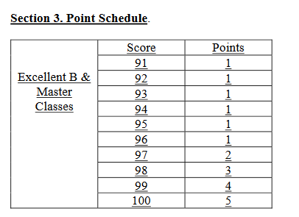

Championship |  |  |  |  |  | Running  Total  Points:
Date: | Adv Q | Excell.  Score: | Excell. points: | Master  Score: | Master points: | Running  Total  Points:

