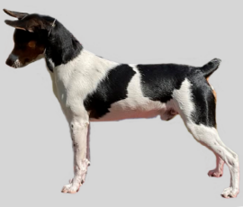
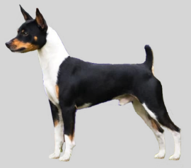
Conformation steps:
PAIR ALL BEHAVIORS WITH THE SHOW COLLAR/LEAD
Socialize to show environments
Collar/lead: Pup is comfortable with collar/lead and pressure from them
Speed: Use a metronome to trot pup for video camera at different speeds to find ideal for straight and curve. Then pick a song with the same BPM to practice those speeds.
Will change as he grows legs? q10 weeks q16 weeks q6 mo. q9 mo. q1 yr
Focus forward:
Teach pup to put feet on flat targets with enthusiasm. Really needs to drive to the targets
Use targets teach pup to trot with forward focus from 1 target to the next
Gradually remove targets and add cue “Strut” between targets. Hold my left arm out to the side with my hand below waist level. Goal is loose leash
Combine moving and “ears” cue
Practice strut “straight” and strut left “curve”
Practice with food on the floor/leave it “Aqui”
Practice indoors and outside on various surfaces
Down and back with Judge focus on return “watch em” (pup will free stack FOR the Judge)
Add free stack with Judge focus after down and back and the regular stack/rock after circle
“Rock” – Teaching pup to freeze in position
Start with general freeze of motion for brief moments
When working on stacking, expect a moment of rock solid stillness of the feet
Add my movement in tiny increments until pup can maintain rock feet as I move around
Work on adding head position with rock steady
Combine ‘rock’ with head position and ears/tail up
“Ears”- get ‘ears forward on cue’ (add a bit of tape to ears so pup focus’ on them)
This can also include focus on a target hand position or pointing to get the desired head position for not only conformation, but general photos also, then “rock” to hold it
Iliopsoas exercises for good form and core strength
Exam: Silent ‘May I touch you’ combined with body stillness- dog on table
Contact all over, show the bite, down each leg, look right in face, grope
May I touch you done by someone else- dog on table even before stack is solid. w/wo collar
Foot targets- Shape pup to put front feet on foot target (bar shape)
Shape pup to put rear feet on foot target (bar shape) Work the following on table and ground:
Gradually reduce the size of the foot targets till they are slightly bigger than paws (4 indiv.)
Get pup happily hopping onto the targets and adjusting his feet himself. Rear feet are ½ a paw wider than front feet. Get short duration. Rock even with me moving around/away
Work on paw targeting flat targets (pieces of carpet, or thin wood) from motion.
When solid, remove 1 target at a time
Work on Rock duration and then my distance for free stacked feet position
Add head position and ears/tail up expression to the stack behavior for finished product
Add “show off” cue when behavior is solid (ground and table)
Add handling of whole body by me during “rock” on table
Add handling of body by several other people qqqqqqqqqqqqqqqqqqqqqq
Practice lifting the dog onto the table into a stack (with lead management)
Practice lifting the dog off the table and transition quickly to movement- down and back
Practice moving from a free stack in front of you, facing you, to moving: I cue “strut”, take a few steps back, then pivot and go. (For start of the go around with the group.)
Practice transition from moving to free stack - “show off” cue
Practice stack for Judge after down and then into the circle strut
Practice working near and ignoring other dogs, esp. moving the same direction/following
Practice ignoring food on the floor and bitch in heat- “Aqui-strut” or “Aqui-show off”
Practice having other people/dogs come up to me (simulate congratulations)

Practice these stages/transitions in the ring:
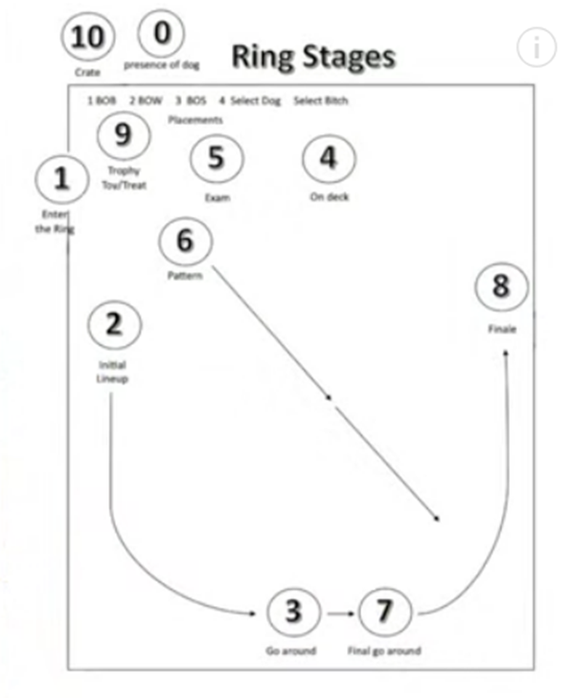
0-Getting the dog out of the crate and to the ring
1-Staging area and entering the ring
2-Line up -duration- tricks that showcase the breed standard
3-Go around- good gaiting where Judge is looking
4-In line and on deck/waiting for the table: stack and purposeful tricks
5-Exam- quick set up, rock and step back
6- Down and back with Judge focused stack
7-Go around- same as 3
8- Finale- present the best free stack. If possible, have the dog ¼ turn toward ring center so Judge can see expression.
-Congratulations by others
9-Awards- reward dog, be happy, let dog carry ribbon

