Counter surfing how to stop it before it starts!
From this trainer: https://trainingcanines.com/
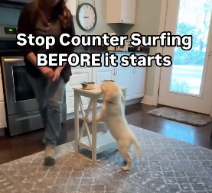
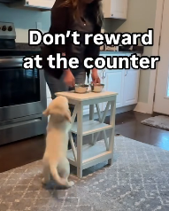Can add a mat
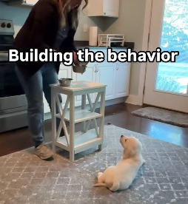 Make it more tempting

Why puppies counter surf:
Their sense of smell takes them to counters. They smell food up there long before they can reach it.
Then you grab something from the counter and hand it to them. Now they think “there’s more up there, I’ll help myself..”
You accidentally taught them counters are where good things come from.
The method:
Use something that they can actually jump on like you see in the reel. Puppies (and dogs) learn by association, so when they do the action you do not want you are able to teach them the action you do want.
Set up food at a height they can reach.
When they try to jump or reach, wait.
When they move away, you reward them away from the counter.
Walk several steps away before rewarding. You’re teaching them to leave the area, not just stop jumping.
Common mistakes:
Tossing or handing them items from the counter while you cook. They quickly learn the good stuff comes from above them.
What to do instead:
Food comes from the floor, or your hand at floor level. Never from counter height.
As they grow:
Keep practicing with real food on counters. Increase temptation as they get bigger. You can also practice this with toys, just place it at the edge of the counter and reward when they do not jump up.
It is actually working on jumping, impulse control, waiting, and countersurfing! An exercise that hits all things.

Your adolescent dog isn’t being stubborn on purpose—their brain is quite literally rewiring itself.
Increased Independence – The attachment they had as a puppy starts to shift as they explore their world with more confidence. This is why recall can suddenly feel unreliable.
Impulsive Behavior – Just like teenagers, adolescent dogs experience changes in impulse control. Jumping, pulling on the leash, and ignoring cues are often due to developing self-regulation, not disobedience.
Testing Boundaries – Adolescent dogs naturally push limits to figure out what works. Without clear guidance, they’ll default to behaviors that work for them—which often means ignoring commands, counter-surfing, or jumping for attention.
But here’s the good news: Adolescence isn’t a phase you have to wait out. With the right training, you can shape their behavior now to prevent long-term struggles.

