Teaching steps and stairs
Puppies are uncoordinated and are rightfully afraid of ‘stepping off’ something that is as high as they are tall! Start with objects that make very low rise steps and gradually increase the height of the ‘steps’ until they are standard height. This will teach them HOW to navigate steps. Ideally, you want to keep the steps no higher than the middle of the puppy’s front legs and increase the height as the pup grows.
You can use books, stiff foam pads, concrete pavers, sturdy boxes, etc. Surface should be non-slip! And stair depth (front to back) should ideally be puppy length or longer. As the pup masters each height of stairs, you can make the depth more narrow to increase difficulty.
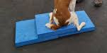
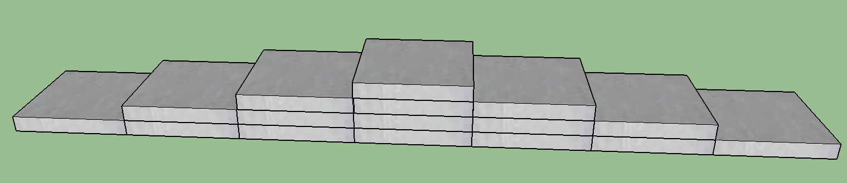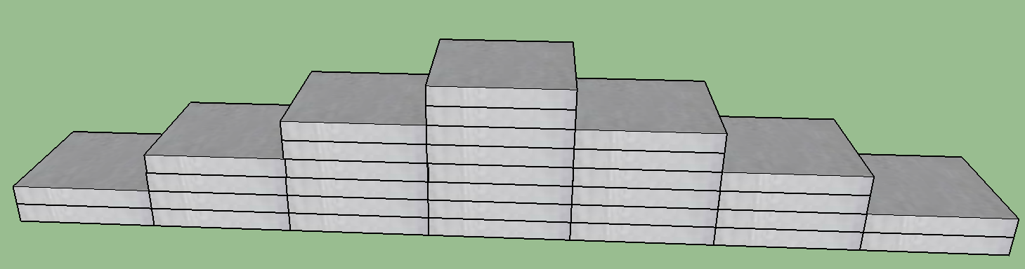
The impact of going down a set of stairs is much harder on the puppy than you might think! It puts tremendous strain on the shoulders and all parts of their front legs. Steep ramps have the same effect, especially if the puppy is going down at high speed or trying to slow down/stop on the ramp. Until the growth plates are closed, the muscles and ligaments have to keep the joints stable.
Don’t practice the puppy steps more than a few times each day. If they are higher than the middle of the puppy’s front legs, only practice a few times 2-3 times a week. And don’t let the puppy do them at a fast speed.
Multiple steps that force multiple repeated impacts with each step (hopping down each step) should not be part of the puppy’s daily routine until about 6-8 months old. Carry the puppy down standard steps until they are big enough to not have hard impacts when going down the stairs. Then, control the decent with a leash so the pup goes down the steps at a walk until growth plates close. Having the puppy in a harness and using the harness to provide some lift of the puppy’s front end as he goes down the steps can help to reduce the impacts of each step without having to carry the pup.

